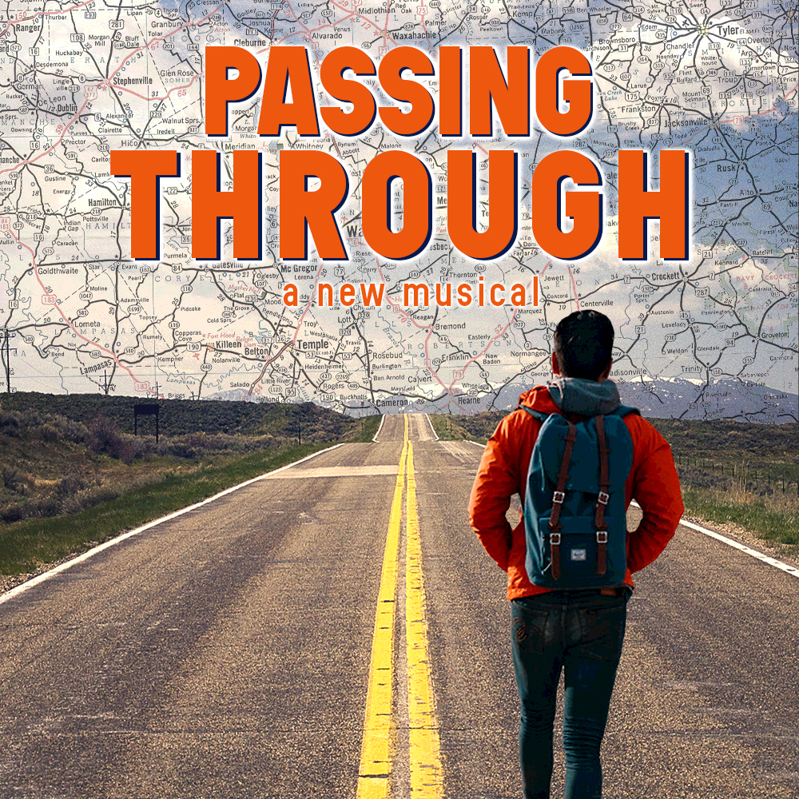­­­

**GOODSPEED MUSICALS PRESENTS**

***Fill in your group’s information below and print on legal size paper.***

**Your Organization Name**

**Performance Date, 00:00 PM**

$00.00

***Event Details:*** Set amidst the rich sounds and diverse tapestry of the American landscape, Passing Through tells the incredible true story of a young man who journeys on foot from Pennsylvania to California, collecting stories as he goes. But when his trek brings to light an unresolved family crisis, he must use the lessons he’s gathered to finally confront his past. Don’t miss the musical that celebrates America and the power of what can happen when we open ourselves up to a stranger.

*Your Contact Info*